**UNIT -1**

**VOCABULARY   WORKSHEETS**

**ROOT WORD, SUFFIX, PREFIX**



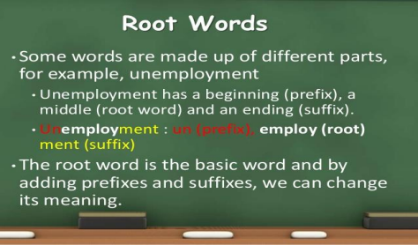

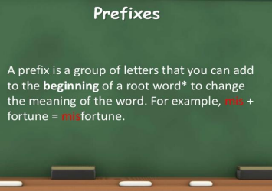

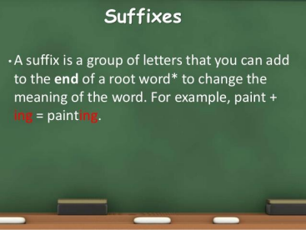

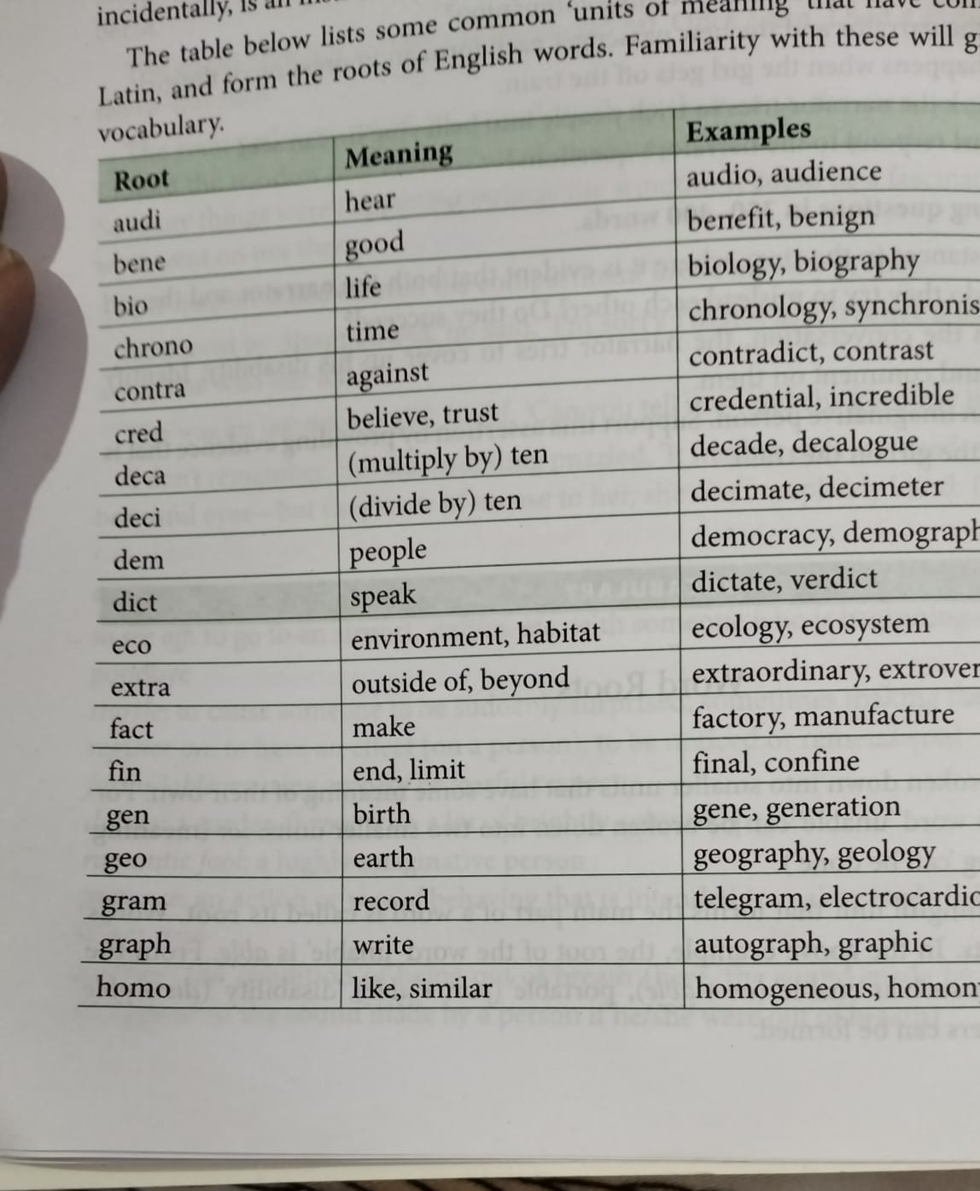

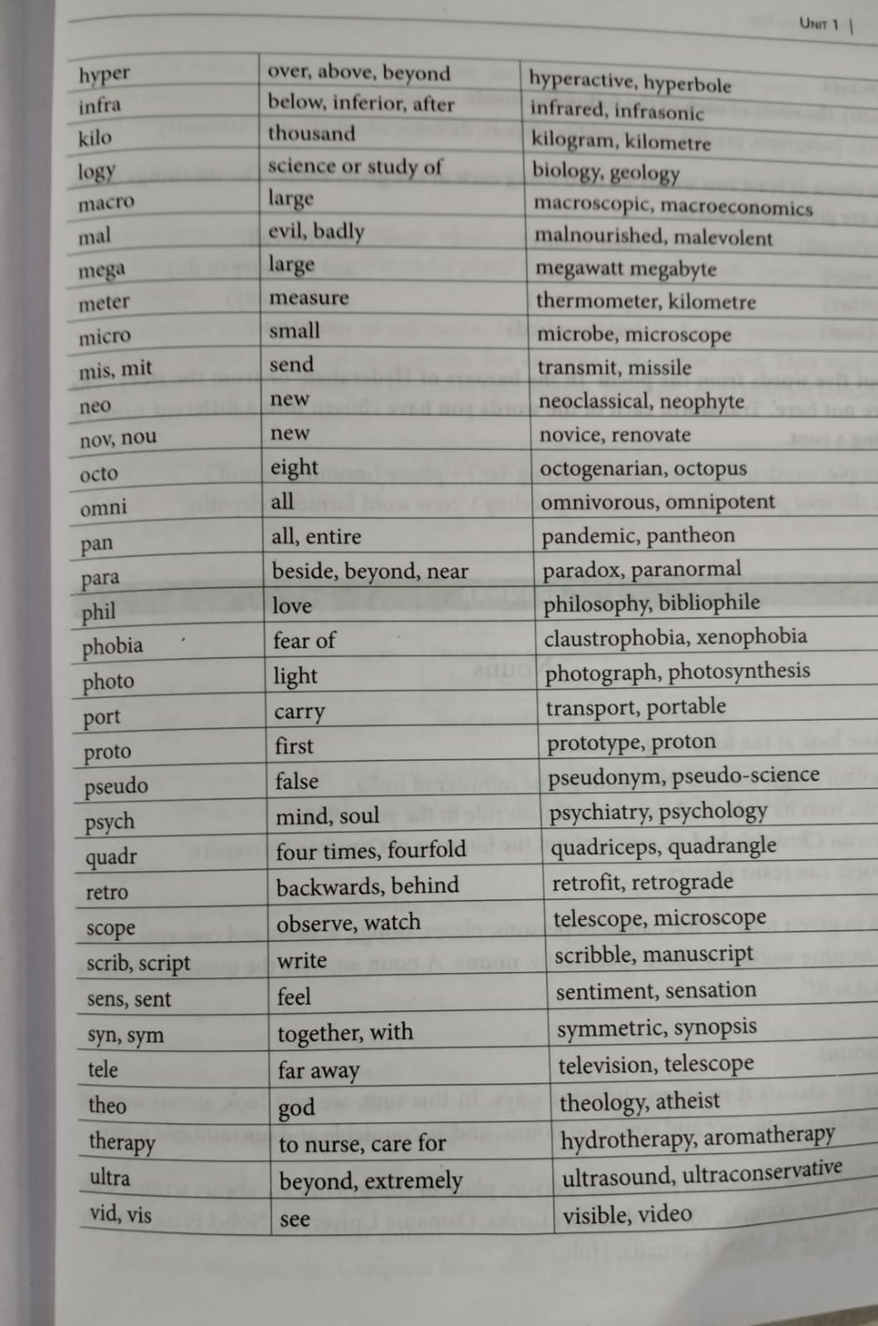

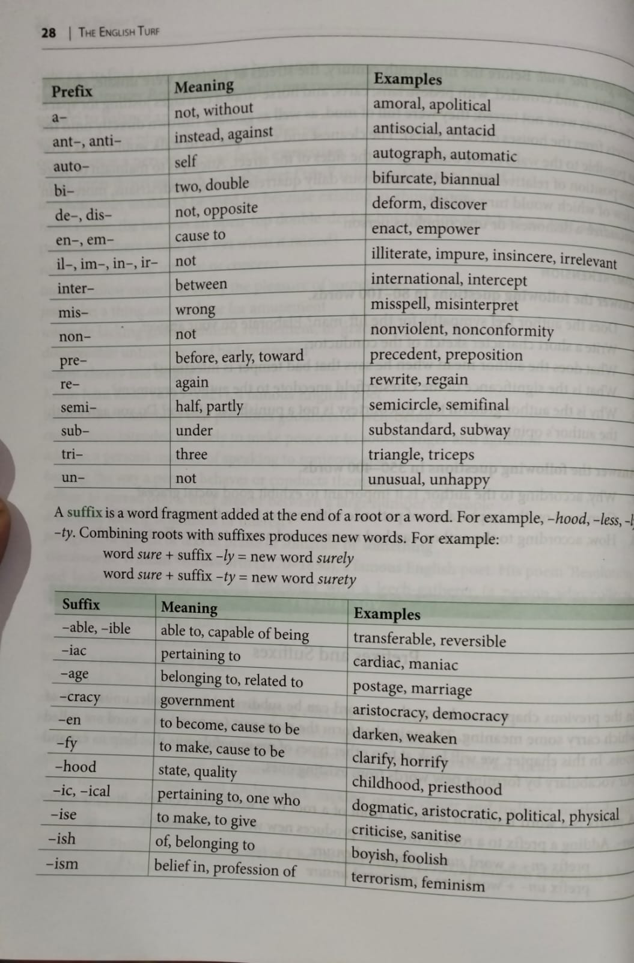

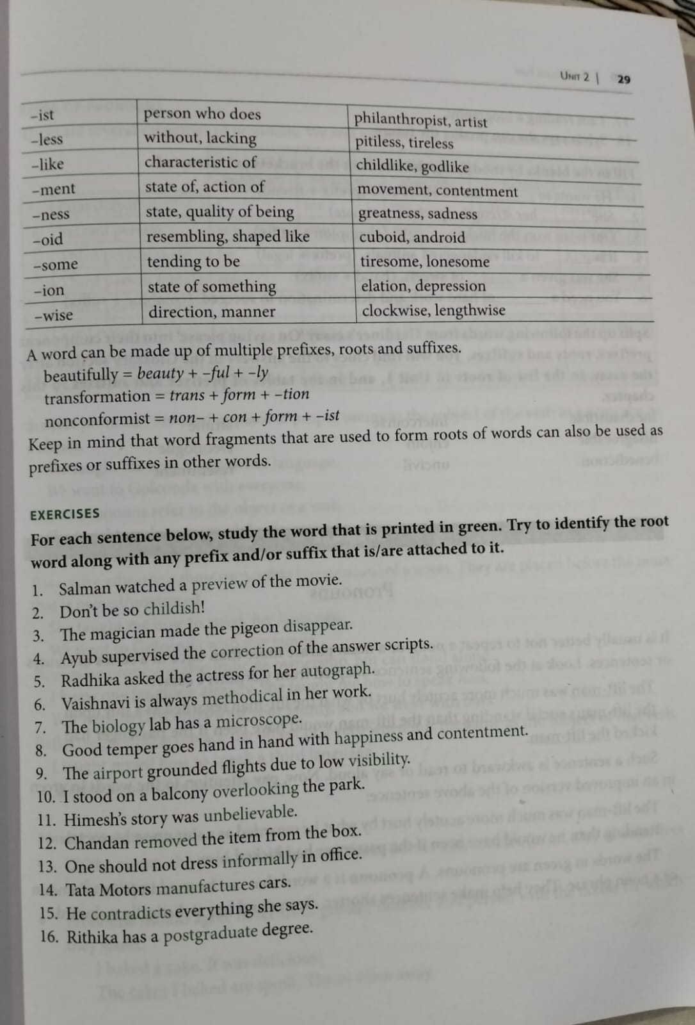

**I .Do As Directed**

**1. We watched a preview of the new Pixar movie.**

**Root: ____________**

**Prefix: ____________**

**2. The dancing cat was seen by more than two-million YouTube viewers. Root: ____________**

**Suffix: ____________**

**3. The teacher handed out paper hearts to the students who had done extra work. Root: ____________**

**Suffix: ____________**

**4. The magician made the rabbit disappear.**

**Root: ____________**

**Prefix: ____________**

**5. At the end of his performance, the magician made a graceful bow to the audience. Root: ____________**

**Suffix: ____________**

**6. Shyla asked the magician for his autograph.**

**Root: ____________**

**Prefix: ____________**

**7. Because of the lightness of the breeze, the sailboat moved quite slowly. Root: ____________**

**Suffix: ____________**

**8. Despite the heaviness of his backpack, Jack raced up the hill.**

**Root: ____________**

**Suffix: ____________**

**9. Some dogs are shy or unfriendly, and they might bark or snap if you try to pet them. Root: ____________**

**Prefix: ____________**

**Suffix: ____________**

**10. Esther quickly reopened the door and called for her cat.**

**Root: ____________**

**Prefix: ____________**

**Suffix: ____________**

**11. We stood on a bluff overlooking the ocean.**

**Root: ____________**

**Prefix: ____________**

**Suffix: ____________**

**12. In today's world, no part of the globe is unreachable.**

**Root: ____________**

**Prefix: ____________**

**Suffix: ____________**

**13. My father never let anyone see him dressed informally.**

**Root: ____________**

**Prefix: ____________**

**Suffix: ____________**

**14. Everyone thought that Mr. Darcy was the proudest, most disagreeable man in the  world.**

**Root: ____________**

**Prefix: ____________**

**Suffix: ____________**

**15. The speaker pointed out the unfairness of blaming high schools for the poor  preparation of college freshmen in reading, writing, and math.**

**Root: ____________**

**Prefix: ____________**

**Suffix: ____________**

**The speaker pointed out the unfairness of blaming high schools for the poor  preparation of college freshmen in reading, writing, and math.**

**Root: ____________**

**Prefix: ____________**

**Suffix: ____________**

**II. FILL IN THE BLANKS BY ADDING APPROPRIATE SUFFIXES**

**1- It's always __________to carry some cash on you, in case of an emergency. (USE)**

**2 - Planning a holiday can be just as __________ as going on holiday. (EXCITE)**

**3 - I found that this medicine is the most _________for colds. (EFFECT)**

**4 - She speaks French __________.(FLUENT)**

**5 - I do not want to get into an ____________with you about this. (ARGUE)**

**6. It can be ______________ to cross the train line so be very careful**. **(DANGER)**

**7. I really like this sofa. It is extremely ______________. (COMFORT)**

**8. We have decided to have our lessons in the garden, as it was a lovely __________________ day.  (SUN)**

**9. John's toothache was quite______________________ and he had to go to the dentist.(PAIN)**

**10. The shop assistant was so ________________or children under 10. There is far too much  violence. (SUITABLE)**

**11. Many people often make a_____________ between London and New York.(COMPARE)**

**12. This book ___________ as a series of lectures about shipwrecks, which were given two  decades ago. (ORIGIN)**

**13. There are power stations across Europe that use the___________ rise and fall of the ocean  tides. (DAY)**

**14. If you weren't so __________ of Ben, he would be happier to spend time with you. (CRITIC) 15. Don't you find it _________ how Jeremy always comes to work looking so untidy? (INTRIGUE)**

**16. Doctors say a glass of warm milk before bedtime can result in amore ___________ night's  sleep. (REST)**

**17. Tim-Berners Lee has received many awards as the _______ of the world wide web.(INVENT)**

**18. I've lost all __________ for this concert, I'm finding it boring. Can we go? (ENTHUSE) 19. The ______________ of the Rubik's Cube peaked in the early 1980s. (POPULAR) 20. The Age Of Enlightenment was one of great inventions an revolutionary____ .(discover)**

**III Put the word in brackets into the correct form. You will have to use  prefixes and/or suffixes.**

**1. He was sitting __________________ in his seat on the train. (comfort)**

**2. There was a __________________ light coming from the window. (green) 3. He was acting in a very __________________ way. (child)**

**4. This word is very difficult to spell, and even worse, it's __________________. (pronounce)**

**5. He's lost his book again. I don't know where he has __________________ it this time.  (place)**

**6. You shouldn't have done that! It was very __________________ of you. (grace)**

**7. He didn't pass his exam. He was __________________ for the second time. (succeed) 8. Some of the shanty towns are dreadfully __________________ . (crowd)**

**9. The team that he supported were able to win the__________________ . (champion) 10. There is a very high __________________ that they will be late. (likely)**

**11. I couldn't find any __________________ in his theory. (weak)**

**12. He wants to be a __________________ when he grows up. (mathematics)**

**13. You need to be a highly trained __________________ to understand this report. (economy)**

**14. There were only a __________________ of people at the match. (hand)**

**15. She arrived late at work because she had__________________ . (sleep)**

**16. The road was too narrow, so they had to __________________ it. (wide)**

**17. He was accused of __________________ documents. (false)**

**18. They had to __________________ the lion before they could catch it. (tranquil)**

**19. He needed to __________________ the temperature. (regular)**

**20. I think that you should __________________ . It may not be the best thing to do.  (consider)**

**21. There was a three-hour __________________ because of the strike. (stop)**

**22. You need a _______________of motivation, organization and revision to learn  English.(combine)**

**23. You must not be ____________to your boss.(polite)**

**24. It is very __________________ to run air-conditioning with the door open. (economy) 25. His __________________ has been expected for the last half an hour. (arrive) 26. I’m _________ to work on weekends.(able)**

**27. I told him my plan but he wasn't very __________________ . (appreciate ) 28. She had no __________________ of going to see him. (intend)**

**29. He spent half an hour __________________ himself with the building. (familiar) 30. Failing her driving test was a great __________________ to her. (appoint) 31. He decided to study __________________ at university. (journal) 32. The film was __________________ good. (surprise)**

**33. There was the need for __________________ construction when the fighting stopped.  (war)**

**34. I don't like him at all. He's so __________________ . (pessimist)**

**35. The company has over 500 __________________ . (employ)**

**36. The new manager was very efficient and a good __________________ . (business)**

**37. It is ______________ to hire children as maid.(legal)**

**38. The rate of __________________ in Brazil has been rising steadily. (employ)**

**39. With the real plan, the rate of __________________ in Brazil has fallen. (inflate)**

**40. She looked at him __________________ , and started to cry. (happy)**

**41. The party was __________________ , everything went wrong. (disaster)**

**42. The film was so __________________ that we left before the end. (bore)**

**43. The film was terrible, I felt really __________________ . (bore)**

**44. I think that there has been a __________________ , I didn't order this. (understand)**

**45. The bacteria are so small that you need a __________________ to see them. (scope)**

**46. Have you seen that new __________________ ? He's very funny. (comedy) 47. The event was totally __________________ . It was terrible. (organise)**

**48. There is a small __________________ explaining the new traffic code. (book) 49. Eating junk food is _________(health)**

**50. He was __________________ . He wouldn't change his mind. (Compromise)**

**WRITING: (GUIDED WRITING)**

**Sample#1** **Importance of moral values at work place**.

**Honest-kind-sense of control –everyone equally- imbibing good qualities-good moral character – looked down by the society-conviction to follow- strong willed- interviewers – job interviews –employee bears- ethical code conduct- disciplined employees –respected –less corruption – fair chance –employers –special attention-selecting employee-unfortunately –not much importance –moral values-growing competition –degradation of moral values –people – do not –hesitate to lie-deceive-spoil work environment - deserving employees lead a lifetime on the same position- immoral practices reach on the top.**

Moral values include being honest, kind, showing respect to others, helping others, having a sense of self control, treating everyone equally and imbibing other such good qualities. A person possessing such qualities is known to bear a good moral character. On the other hand, those who do not possess such qualities are looked down upon by the society. It requires conviction to follow good habits and imbibe moral values. Not every individual is as strong willed to follow these habits. However, we must try to imbibe these. People look forward to individuals with good moral values. One of the things that the interviewer examines during a job interview is whether the prospective employee bears good moral values. Besides the basic moral values, every organization has a defined ethical code of conduct that the employees are expected to follow. An organization with disciplined employees who possess good moral values are respected and regarded. There is less corruption and everyone gets a fair chance to learn and grow in such an environment. This is the reason why employers give special attention to this quality while selecting an employee. However, unfortunately, the youth today does not give much importance to the moral values. The growing competition these days is one of the reasons for the degradation of these values. In an attempt to grow professionally, people do not hesitate to lie, deceive and use other unethical and immoral practices. Finally, I would say that our society needs more individuals that possess good moral values in order to grow and develop the right way.

**Sample#2: IMPORTANCE OF PARENTS IN ONE’S LIFE**

Parents-biggest role-career development – precious gift-overcome negative attributes and insufficiency unconditional love - train – pillar of strength- future challenges -education respect-sacrifice-reduce cost of living- work hard-guidance and support-Difficult times motivate-inspire –guidance and support –help us to live -! Life is beautiful- Live happily *******************************************************************

Parents play the biggest role in our life. Father & Mother play important role in our mental, physical, social, financial and career development. They help us in every step of our life. Parents are the most precious gift of God for humans. They are the ones who help the child overcome negative attributes and insufficiency. We are blessed to have their unconditional love and support. When we are happy then they are happy. During our tough times, they are like pillar of strength teacher. They train us very hard to face future challenges of life. Parents do almost all the things to make us educate and be well respected in the society. They sacrifice and reduce their own cost of living for the future of their children. They provide each and everything to us. Parents work hard day and night for their children’s education. Indeed, they feel proud of us when we are successful in our life. Their guidance and support help us to live the life we always wanted. Respect your parents and live happily! Life is beautiful when you are living along with your parents. Live happily and keep others happy.

**Sample#3 : BRAIN DRAIN IN INDIA**

Experts- scientists, engineers, doctors- migrate from under-developed countries- settle downcalled “Brain Drain- problem- India- being faced by almost all- Brain drain results- direct lossunderdeveloped and poor countries- train these experts at a great cost- these experts migrateget the services of the experts- without having- spend anything- According to a U.N.Othousands of experts- U.S.A., U.K., Canada, Germany- number of factors-lacks job opportunities- do not get any employment in India- do not recognise talent- offered lucrative jobs

**********************************************************************

When highly qualified experts like scientists, engineers, doctors and often trained persons migrate from under-developed countries and settle down in advanced countries, their migration is called “Brain Drain“. This problem is not peculiar to India alone. It is being faced by almost all the developing country of the world. Brain drain results in direct loss to the underdeveloped and poor countries who train these experts at a great cost. When these experts migrate to advance countries, such countries stand to gain because they get the services of the experts without having had to spend anything on their training- do not recognise talent- lacks facilities for advanced research- lacks facilities for advanced research- go abroad for higher research do not return to IndiaAccording to a U.N.O. report, thousands of experts migrate from backward countries like India to highly advanced countries like the U.S.A., U.K., Canada, Germany, etc. U.S.A. has been the biggest gainer from the brain drain in India. There are a number of factors responsible for brain drain in India. First of all, India lacks job opportunities. When, after completing higher studies, people do not get any employment in India, they start looking forward to advance countries for jobs. Secondly, we do not recognise talent in our people; Thirdly, India lacks facilities for advanced research. Most of the students who go abroad for higher research do not return to India. They are offered lucrative jobs so that they may stay on in advanced countries and give these countries the benefit of their research. All the doctors, scientists and engineers should realise that they owe some duty to their country. Our country spends lakhs of rupees on their training. On becoming experts, they should not betray their country by serving foreign countries. They should have a feeling of gratitude to their country.

**Sample#4 : A Rich farmer**

- lot of land - cattle and servants - two sons - happy life - After some years younger son unhappy - asked for his share of the property - wouldn't listen to father's advice - got his share - sold them all - went away to another country - fell into bad ways - soon all money gone - poor - no one to help him - understood his mistake. ***********************************************************************

Once there was a rich farmer in a Village. He had a lot of land, cattle and many servants. He had two sons. He led a happy life with them. After some years the younger son became unhappy. He asked his father for his share of the property. His father advised him not to demand like that. But he would not listen to his father's advice. He got his share and sold them. He had a huge amount with him. With this amount he travelled to a distant country. He had bad company there and fell into evil ways. All the money was gone. He became poor and no one helped him. Then he understood his mistake and returned to his country. His father and brother took him into their fold and supported him forever. We should obey our parents .

**Sample#5: The illiterate boy**

……… caught for pick pocketing…….sent to juvenile prison………forced to do lessons………becomes sullen rebellious ……..watches French comic film on T.V. during recreation hour……..fascinated with the language……….requested coaching classes………a French tourist guide today ***************************************************************************

Raju was a little boy who was born in a poor family. He wanted to get education but his financial condition did not allow him to do so. He remained illiterate and so did not have any means of earning. He took to pickpocketing and small thievery. One day, he was caught red-handed for pick-pocketing. Since he was only thirteen, he was sent to juvenile prison where he was forced to do lessons. He had no interest in them and the compelling behaviour of the prison-people made him sullen and rebellious. It was only during the recreation hour that he seemed to be his normal self. One day he watched a French comic film on T.V. He was fascinated with the French language and wanted to learn it. He requested the prison authorities for coaching classes in French. They agreed to his proposal as they were themselves interested to make him learn something so as to be self-dependent. Raju showed a keen interest in learning the language and in a very short period, had acquired a mastery over the language. Raju was set free after two years. He had already decided to use the French language as his means of earning. He became a French tourist guide and started leading an honourable life. He forgot all about his past and is happy these days for the sudden but positive turn in his life. He has set an example for others that man is a master of his own destiny.